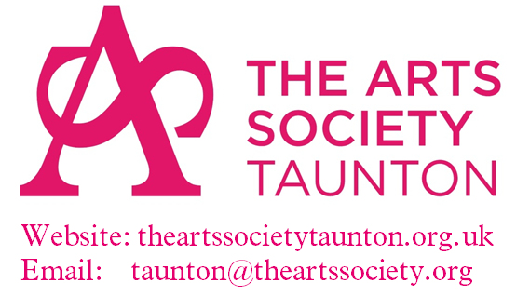

**Method or Madness?**

**with Sarah Cove**

**John Constable’s Painting Materials & Techniques**

**Thursday 20th November 2025 10.00am – 3.00pm**

**Cheddon Fitzpaine Memorial Hall, Taunton, TA2 8JY**

“Private Collection, Images under strict copyright © Sarah Cove ACR, Constable Research Project. All Rights Reserved”

People think they know Constable through images on chocolate boxes and biscuit tins but often they don’t really understand his most familiar works! Sarah Cove is on a mission to open the eyes of the public to Constable as the ‘*Jackson Pollock of the 1830s’*. She will show us that, in many ways, he is a true ‘*Father of Modern Painting’* through his influence on the French 19th century landscape tradition that led directly to Impressionism, Cezanne and ultimately Picasso!

***This study day will leave you reeling from the abundance of amazing images! You will never think of Constable in the same way again - guaranteed!***

*Sarah Cove ACR has worked as a painting conservator, technical art historian and lecturer since the mid-1980s. She runs a conservation studio in Falmouth, Cornwall, where she works on paintings and frames for private and heritage clients. Having trained at The Courtauld, she founded the Constable Research Project in 1986 and is now the recognised authority on John Constable’s painting materials and techniques. She has published widely including essays in Tate’s ‘Constable’ (1991) and ‘Constable: The Great Landscapes’ (2006) exhibition catalogues. She has lectured for The Arts Society since 2003 and at major museums, galleries and conservation venues worldwide. She has appeared in a number of TV programmes including ‘Constable in Love’ with Andrew Graham-Dixon and BBC’s ‘Fake or Fortune?’ in 2014 and 2017. Constable is the only painter to be featured twice on the show during which Sarah was instrumental in the discovery of three new Constables!*

**Programme**

***Registration and Coffee 10.00am***

***Session One 10.30am – 11.30am***

***Method or Madness: Part 1:*** In a chronological presentation Sarah Cove will show the highlights of her research including many of John Constable's famous oil sketches, the ‘six-foot’ canvases and his extraordinary late oils. Her talk also demonstrates the effectiveness of an in-depth study of the work of a single artist in terms of developing a secure chronology through the dating of materials and techniques and how this acts as an aid to attribution. She has been instrumental in the discovery of more than a dozen ‘new’ Constables in the past few years.

**Session Two 11.50am – 12.50pm**

***Method or Madness Part 2***

***Lunch***

**Session Three 2.00pm – 3.00pm**

***The Treslove Portraits***: Until 2019, when it was brought to Sarah Cove for cleaning and restoration, the whereabouts of Constable's sumptuous portrait of his neighbour in Charlotte Street, Mrs. Emily Treslove, was unknown. The portrait of Emily in all her finery is arguably one of Constable’s finest. Following the 'discovery' of Emily's portrait, its companion, a portrait of Emily’s husband Thomas (1775-1841) came to light. Sarah has cleaned, restored and examined both paintings, and she has had privileged access to the key diary volume and the garnet jewel (worn in the painting). A story of excessive wealth, vanity, fashion and politics is revealed in this lecture, illustrating how the technical study of Constable’s paintings, alongside his letters and the sitter's diaries, widens our understanding of his portrait practice and the frivolity of the nouveau riche in the early 19th century.

✂✂✂✂✂✂✂✂✂✂✂✂✂✂✂✂✂✂✂✂✂✂✂✂✂✂✂✂

**Special Interest Day Thursday 20th November 2025**

**Cost £42 including coffee on arrival, buffet lunch and a glass of wine**

Guests who are not members of our society are very welcome.

**Please return this form to The Arts Society Taunton to: Margaret Way,**

**Special Interest Day Organiser, The Weavers, Church Lane, Kingston St. Mary, Taunton TA2 8HR or**

**email your booking details to Margaret Way at**:[Specialinterest.taunton@theartssociety.org](mailto:Specialinterest.taunton@theartssociety.org)

Payment by BACS is preferred:

Account name: The Arts Society Taunton, account number - 35802160. Sort code 30-98-45. Ref: ‘your name’

Or please post a cheque to Margaret Way at the postal address shown above

Name ……………………………………………………………...............................................................................

Telephone No………………………………………… Email ………………………………………………………….

Number of places at £42 ………. Total £……………

Names of other attendees………………………………………………………………………………………………

Dietary requirements for all attendees ……………………………………………………………………………………